STM32N6570

OUR MOTOR: Electric Motor for a Scooter QS260 5000W V4 High Power 12 inch Motor with Detachable Rim see “Product Description”
continuous current: 77A at 72

OUR MOTOR CONTROLLERS: Kelly Motor Controllers Mini KLS9620M Nominal V: 48-96V Max V: 36-115V 200A 100A**

SimpleFOC boards
shield: stacks directly on top of a microcontroller board w/ headers, which solves wiring/integration
SimpleFOCShield: $35, 3A/35Vin
SimpleFOCDrive: $50, 20A/30Vin
Vout depends on external power supply…

** figure out control signal & motor voltage in **

arduino SimpleFOC library
supported hardware:
bldc motors: their high performance motors are ~20A/35Vin, 0.1Ω. apparently the rest of this voltage goes towards backEMF? idk that doesn’t really sound right to me

bldc drivers: keep in mind our motor is 3PWM obviously, other than that def should look into these off the shelf components
**check stall current before running the motor**

hall sensors: included on our motor, effectively spaced 120 degrees apart. determines which 60 degree section you’re in.
guide i found really helpful
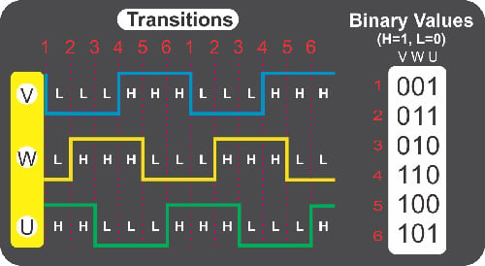

microcontroller:
- processing power (expected loopFOC() in kHz) -> unsure how we’d calculate this
- PWM generation capabilities -> def look more into using FPGAs for this, cause I feel like it’s not that trivial
- ADC sensing capabilities -> also probably need a peripheral for this? or we do w/ microcontroller

writing the code:
getting started guide: makes more sense in parallel w/ or after everything else
- sensor test (rotate and see if angle/velocity of hall sensors are right)
- driver test (set PWM outputs and test w/ multimeter)
- open-loop test (motor spins at target velocity. **this finds pole pair count**)
- closed-loop test (torque/velocity/angle motion control work on voltage mode)
- estimated current control test (torque motion control works on estimated current mode)
- foc current control test (current sensing is good, torque motion control works on foc current mode)

bldc motors: this is the overall flow of things, but all of the code is doing the settings
- motor parameters
- linking sensor/driver/current sensor
- setting PWM modulation type, alignment parameters
- setting torque control mode
- setting motion control mode
- initialize motor (motor.init()), align hardware components (motor.initFOC())
- loop w/ motor.loopFOC() and motor.move(target)

important!!!
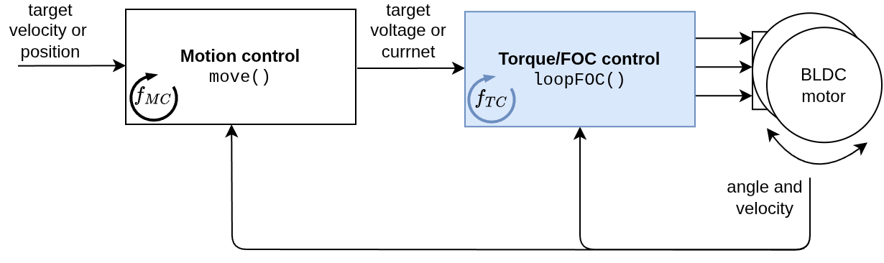

bldcDriver 3pwm: ummm i guess their driver class is doing the PWM signal generation along w/ the amplification???
- set PWM freq, power supply V, driver output V
- initialize (prep for PWM)

standalone driver section maybe useful

hall sensors:
- pullup config (cause they’re open drain) & velocity outlier removal
- interrupt discussion -> FPGAs do not have those lowkey!!!

current sensing: unsure how this component integrates/attaches physically, hmmm. also types. but this just gives you access to d and q axis current

torque/foc control loop: TARGET TORQUE (V/i) -> PHASE VOLTAGES. review block diagrams
LOOPFOC()

voltage mode (none)
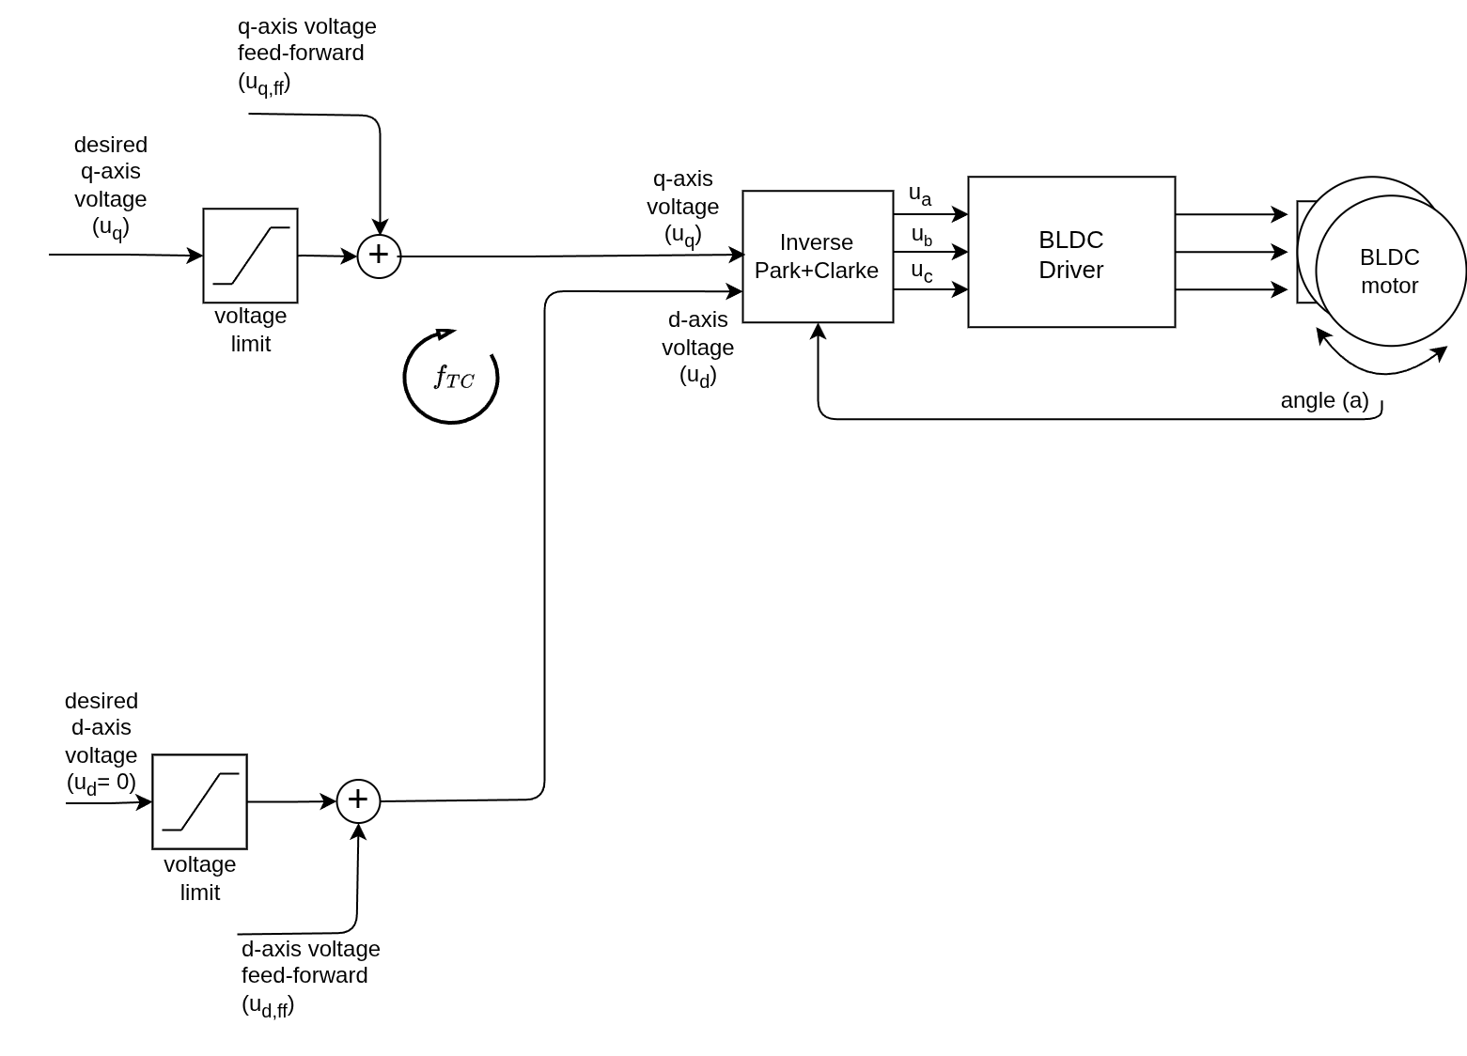
where is the Park/Clarke?? what is giving this uq and ud?

- does NOT account for backEMF, no current sensing
- parameter: motor voltage limit

(voltage controlled) estimated current mode (phase resistance, KV rating, q and d axis inductance)
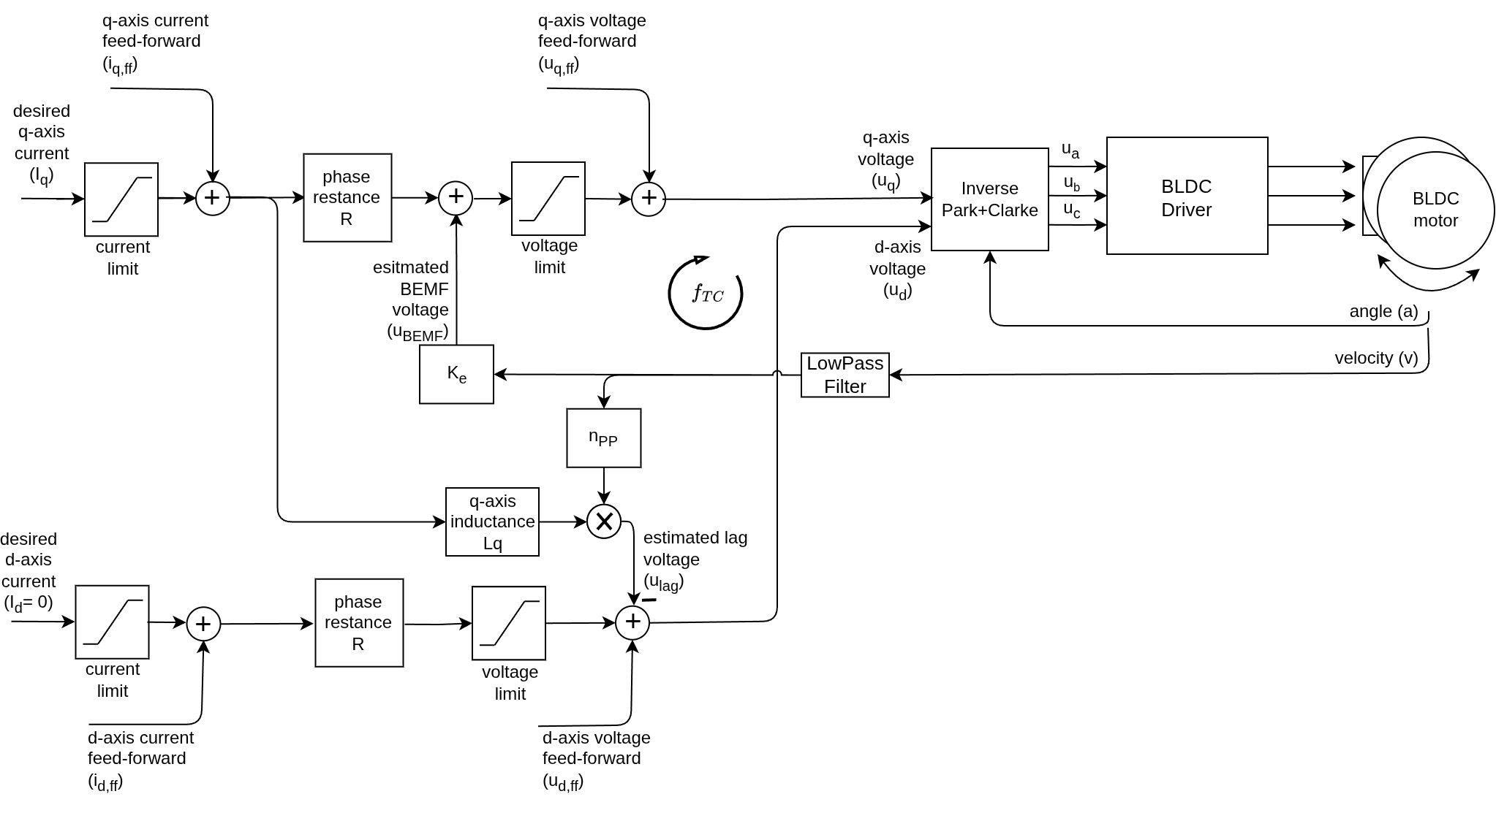
LOOK MORE INTO SPECIFICS OF THIS DIAGRAM

- accounts for backEMF, no current sensing
- parameter: motor voltage limit
- to read: lag compensation; [Targets, Limits and Feed-forward]

(q/d current controlled) FOC current mode (PID controller parameter iq/id, LPF time constant iq/id… both tuned)
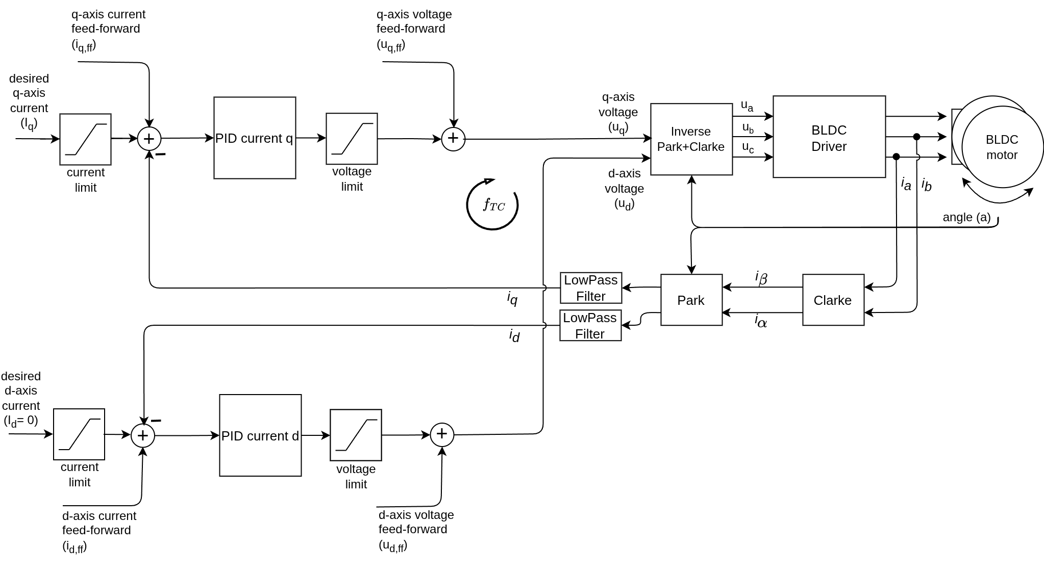
this one also confusing

- accounts for backEMF, yes current sensing
- parameter: motor current limit
- to read: lag compensation; [Targets, Limits and Feed-forward]

don’t think we want DC current mode

motion control: TARGET VELOCITY/POS -> TARGET TORQUE (V/i)
closed loop: w/ feedback
******** torque control: directly giving target voltage/current out ********

velocity control: input velocity, use PID controller for target torque
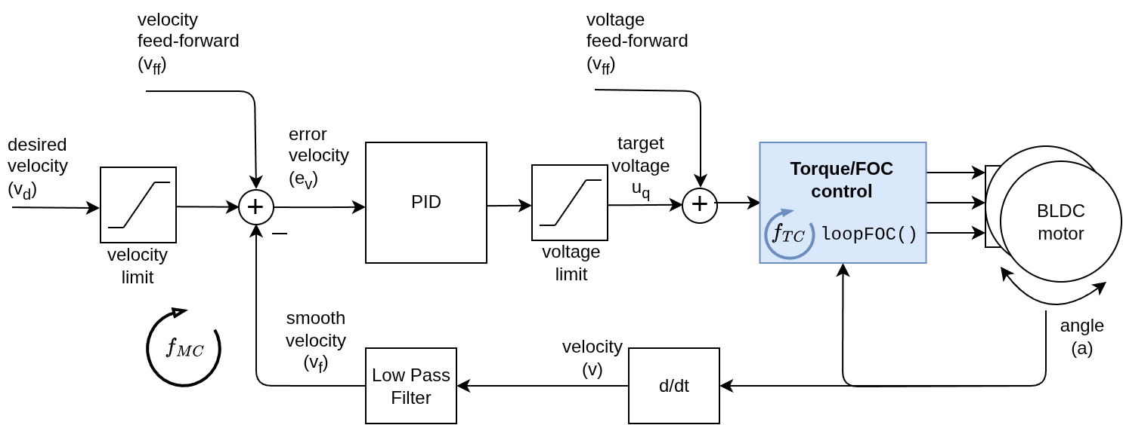
- PID controller filters motor velocity, sets target torque so that it’ll reach/stay at input velocity (P/I/D are all parameters)
  - P determines proportional gain: error; process variable minus target
  - I determines integral gain: sum of error over time
  - D determines derivative gain: rate of change of process variable
  - sum these components for PID output (which drives the process variable)
- low-pass smooths out motor velocity (low-pass time constant is a parameter)
- see diagram for feedforward variables

position control: input angle to target torque
cascade (P + PI): angle controller sets velocity target -> velocity controller sets torque target
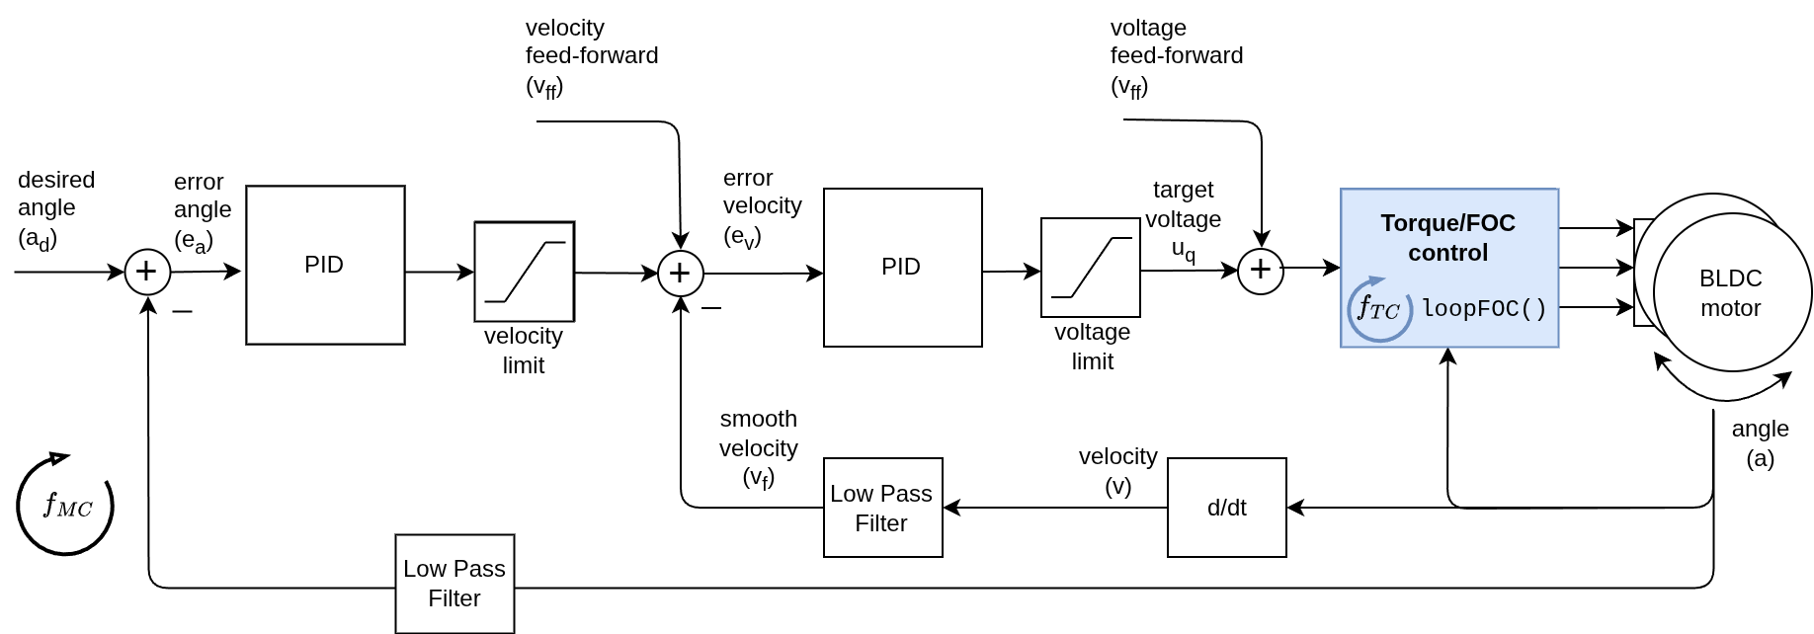
- adds another PID controller and an optional low pass for the angle
- angle PID just uses P, velocity PID just uses P and I
- do not understand benefits section (velocity & torque limits)

non-cascade (PD): angle controller sets torque target (LESS RECOMMENDED)
- ok same principle, cutting out the velocity PID

open loop: w/o feedback, so no position sensor (otherwise same principles); assumes motor is following target velocity/pos
velocity open loop:
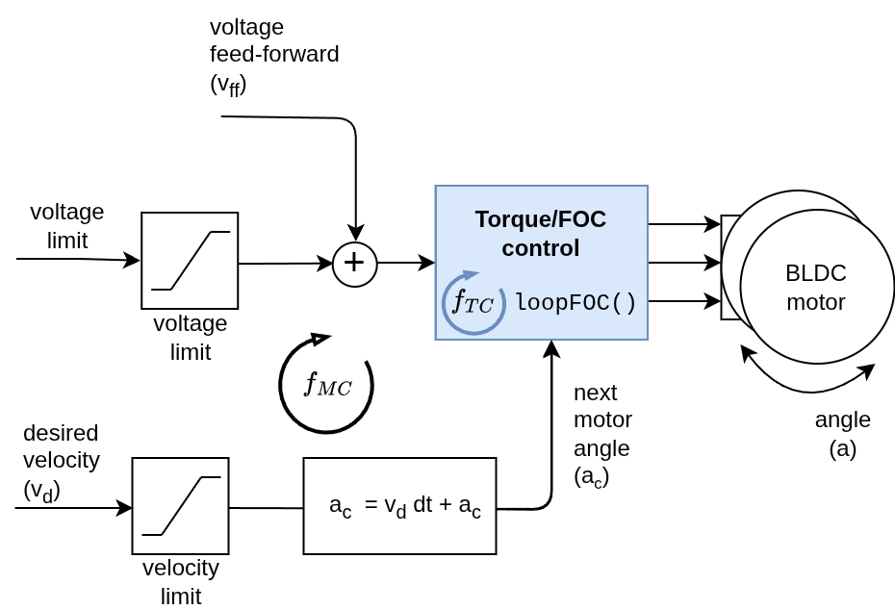
- always gives max voltage bc it doesn’t know current velocity
- calculates next angle with formula above (dt is adaptively calculated)

position open loop:
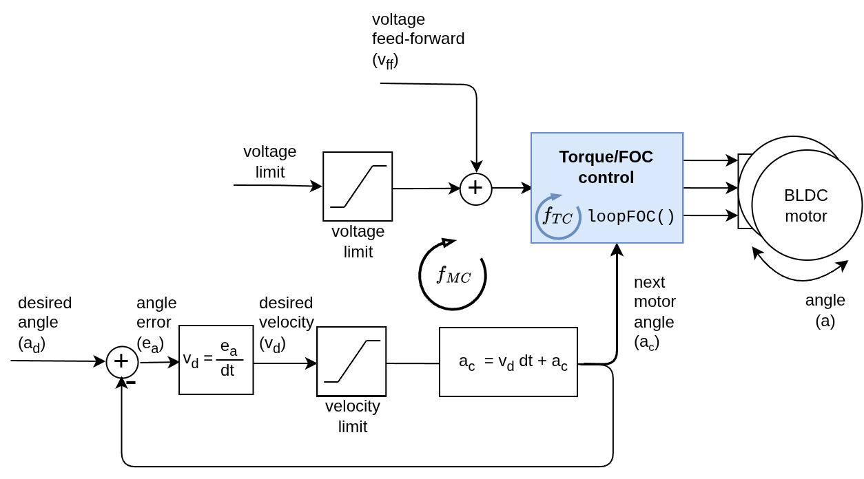
- always gives max voltage
- finds direction from desired angle minus current angle, goes in that direction w/ highest possible velocity
- aka constrains ad - ac between -vmax*dt and +vmax*dt (if close enough, sets ac to ad? does that make sense)

this version of the formula makes more sense to me:
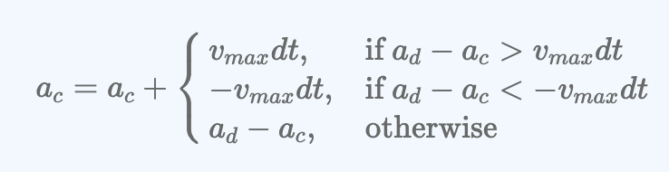

monitoring: outputting/serial plotting of key variables!
communication: commander interface! (real-time config)
debugging: Serial w/ less effect to loop timing!

practical guides:
PID tuning:

motor parameters & characterization:
necessity: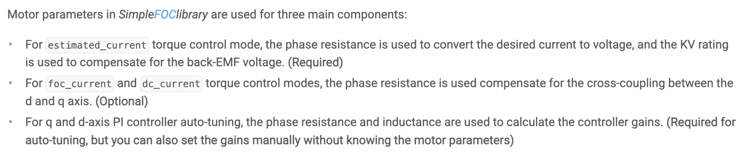

phase resistance - DC resistance of a single motor winding: multimeter or voltage source & measure current (more accurate) +what is our motor resistance

kv rating - number of revolutions per minute (rpm) the motor will turn per volt applied: see method

testing & tuning motor parameters
inductance value - determines the d-axis (IT SAYS D BUT USES Q IN ALL THE CODE???) voltage needed to prevent lag at high speeds: lowkey don’t get this, see method

- more granular overview of how to get parameters
- troubleshooting

characterizeMotor() - provides phase resistance, Ld and Lq
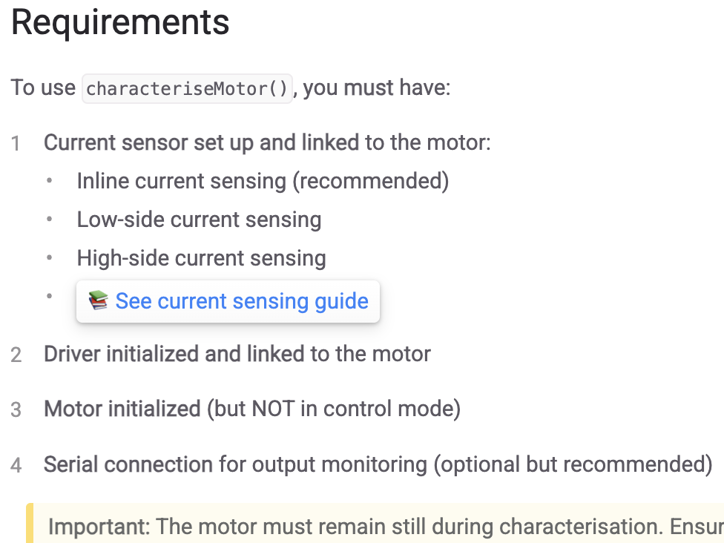

theory corner:
torque control methods in FOC: to read, lowkey very crucial i think

coordinate transformations in FOC:
frames:
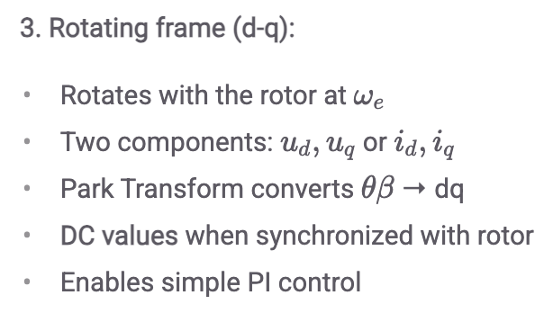
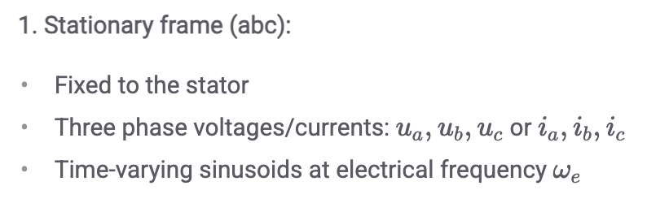
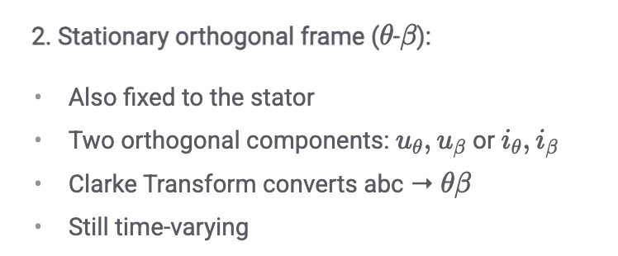
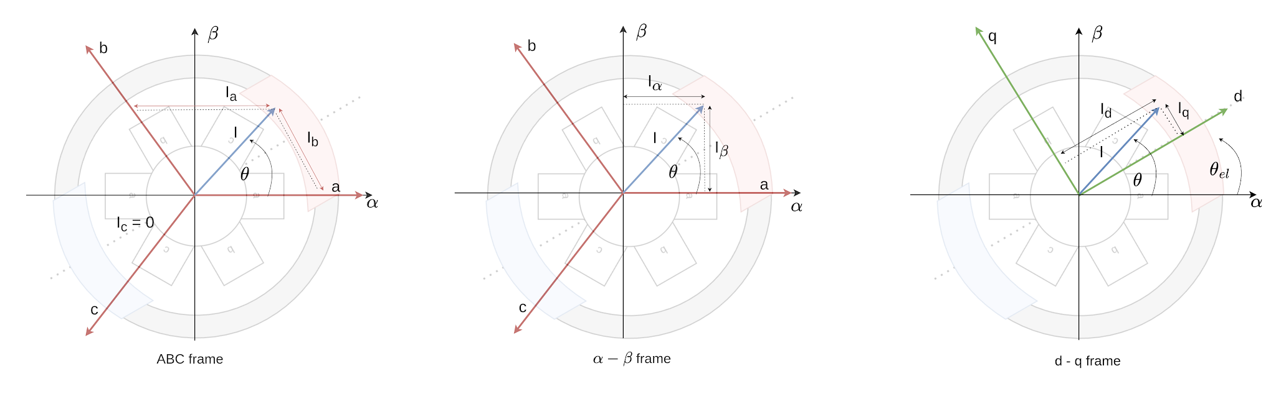

current in d-axis should go to 0 so all current goes to q axis and therefore torque

Clarke transform (abc to θβ) -> 3 phase(120 apart) to 2 phase orthogonal
Park transform (θβ to dq) -> rotates axis from stator to the rotor

normal versions to turn control signal into FOC calculation
inverse versions to turn FOC calculations back into phase voltages

pwm modulation: should def look into this/test this, especially space vector, bc i was under impression sine was the best
- sinusoidal -> start here…
- space vector
- trapezoidal -> is our backEMF trapezoidal??

motor & sensor alignment:
formula for torque, actual point is j we want stator current & rotor current perpendicular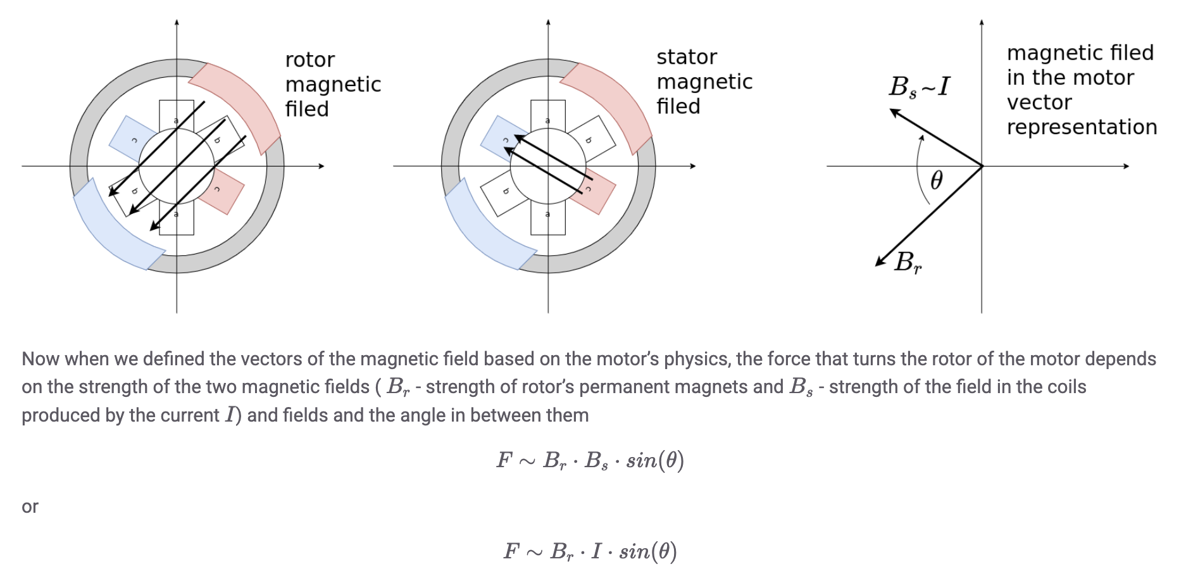

didn’t pay attention to the actual initialization stuff LOL

current sense align: very intuitive, takeaway is it’s important to determine corresponding sensor to phase & polarities

